Michal Bochenek  
EC1401916  
  
  
  
  
  
  
  
  
  
  **Outcome 2:**   
**Design a website for specified devices using the principles of software planning and design.**

**Table of contents:  
  
1. Scope of a project.  
2. Design specifications and requirements.  
3. User expectations.  
4. Analysis.  
5. Algorithms.  
6. Graphical solution – project plan (presentation of the webpage design).  
7. Test the design.**

1. **Scope of a project.**In this scenario we were employed to create and design a responsive cinema webpage for different mobile devices with options to create account, logging in, booking tickets and other necessary functionalities which are described later in this document.   
     
   This outcome covers the production of the design documentation including a prototype of the website with an optimisation for the mobile usage.  
     
   We are also required to provide evidence of understanding in our work of:  
     
   - Scoping a project   
   - Design specifications   
   - Understanding of device requirements   
   - User expectations   
   - Analysis   
   - Design techniques   
   - Algorithms   
   - Graphical solutions   
   - Project plans   
   - Testing
2. **Design specifications and requirements.**   
     
   **Requirements are:**

- design part must cover cases of scalable website using 12 column approach for multiple screen resolutions like tablet, small smartphone, phablet and laptop screens

**-** web page must be ergonomic, user centred and up to date with current design standards and the minimum features are shown below

**Our design has to contain and show complete webpage navigation with features such as:**  
**- homepage:**   
  
page navigation (menu button on top of the screen) with hiding side panel for the menu available at all subpages  
  
showing what is available at the cinema, for all mobile devices it will be shown as a scaling carousel on top of the screen with links to the movie information  
  
premiere - in the middle of the page displaying newest upcoming movies with links  
  
coming soon – announced releases of the incoming movies displayed after premiere part of the middle page  
  
**- hide-able side panel menu:   
accessible from menu button in the top right corner of each page**  
home – takes us back to the main page  
  
buy tickets – book&buy tickets takes us to the booking subpage  
  
contact us – contact with the website administration/cinema  
  
login/register – takes us to the registration subpage   
  
**- login/registration:**create new account - button opens form to register a new user account on the server  
  
login – opens a form to log to the page using previously created user account  
  
remove account – opens a form which removes all data stored about user account  
  
**- buy tickets:**checks if user is logged in, opens a cart with tickets for available movies at the cinema, at this subpage user can finish, modify the order and pay for the tickets  
  
- **movie subpage:**displays movie subpage with booking buttons for several display times which adds the movie to the booking cart

1. **User expectations.**After conducting a short research we could conclude that a typical user expects this kind of website to be as simple and transparent as it is possible, with recognizable graphics and titles for each movie (like a movie poster) and high level of detailed information about availability or release date.  
   Users want to navigate the page in as short way as possible starting from the homepage where they are probably going to find movie of interest for them to booking a ticket for the display after fast login or creating new account.
2. **Analysis.**To create the design we have to use 12 column approach which allows us to show the different instances of the webpage in comparison with other devices on which it will be accessible.   
   Furthermore the interface and page layout must allow user effectively use his fingers as a pointer for smartphones also with tablet or other touch-screen devices.  
   Pictures below represent typical accessibility ranges for the user at the touchscreen, this is example how we should think about designing a layout and navigations for the project.  
     
   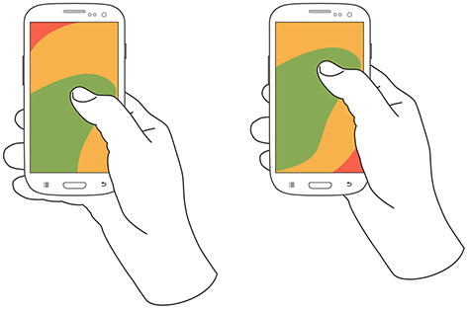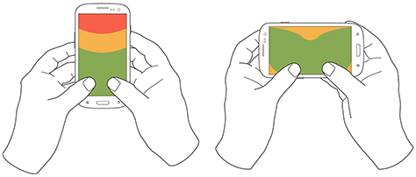  
   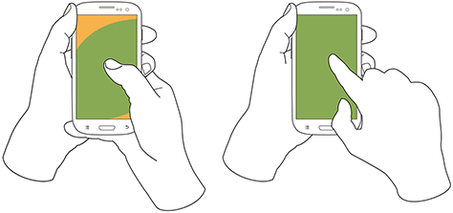

1. **Algorithms (showing website navigation see next page):**

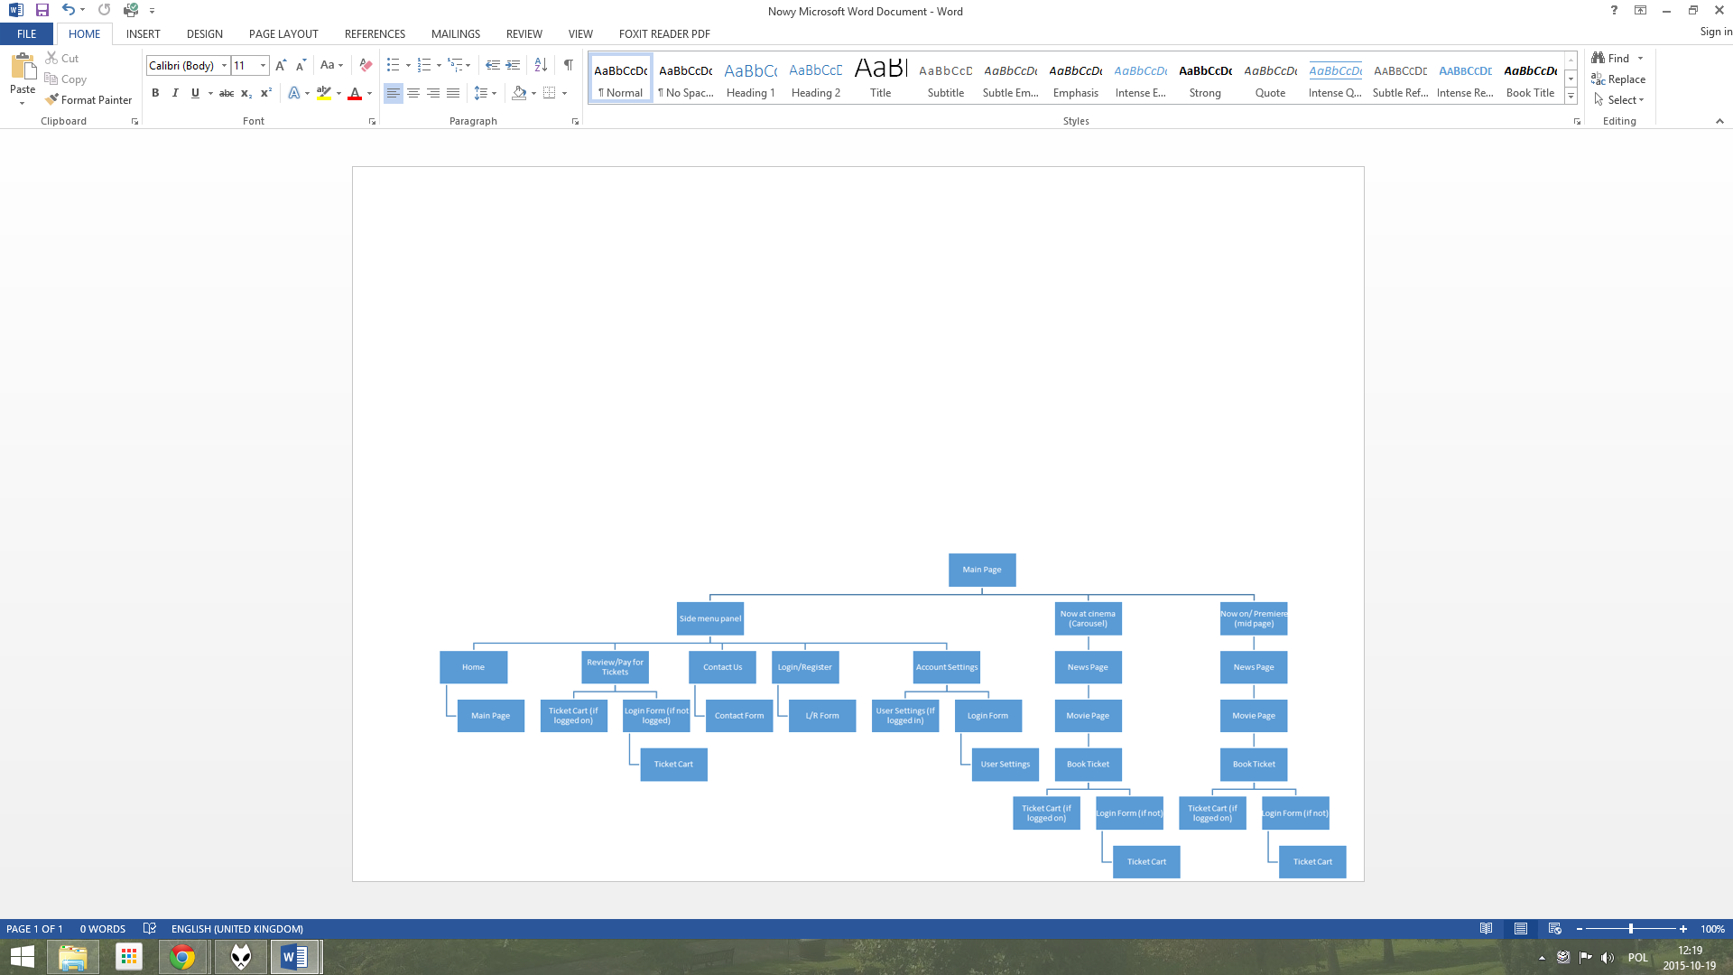

1. **Graphical Solution – Project Plan (using 12 column design)  
     
   For desktop / large screens:**

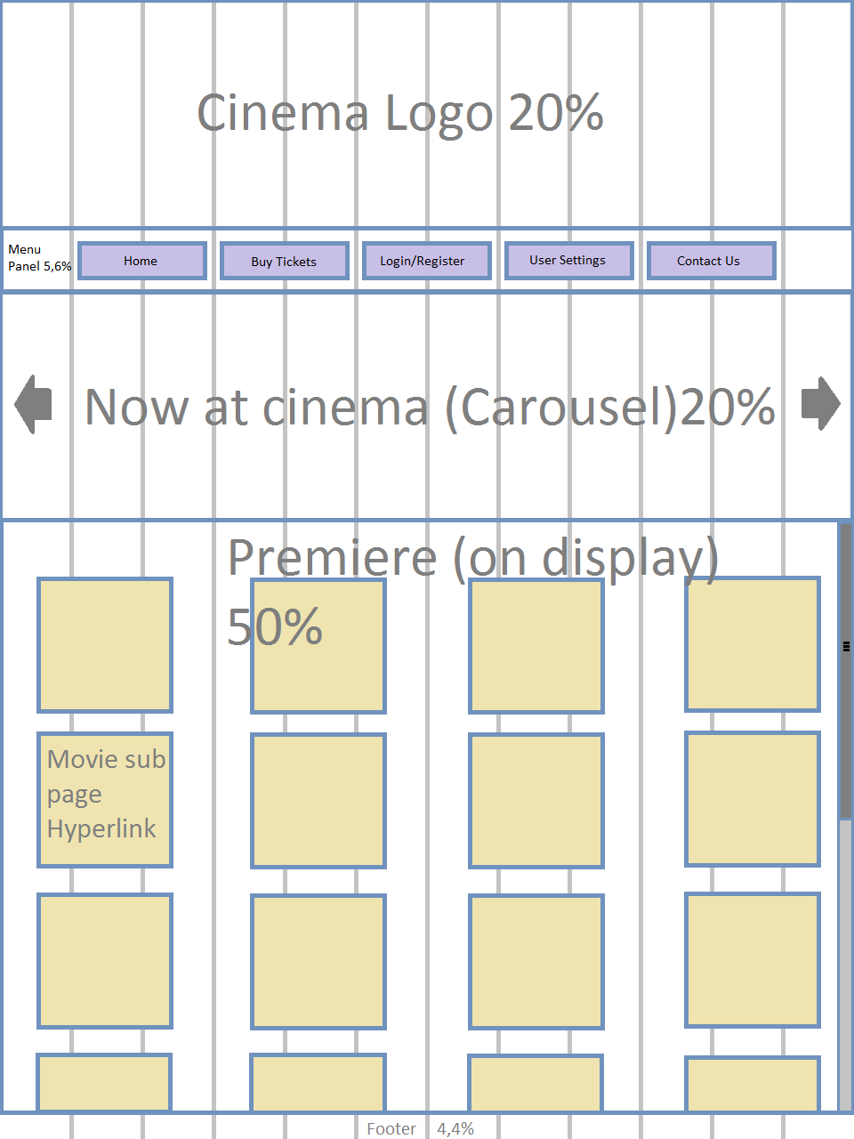

**For tablet / medium size screens:  
  
  
  
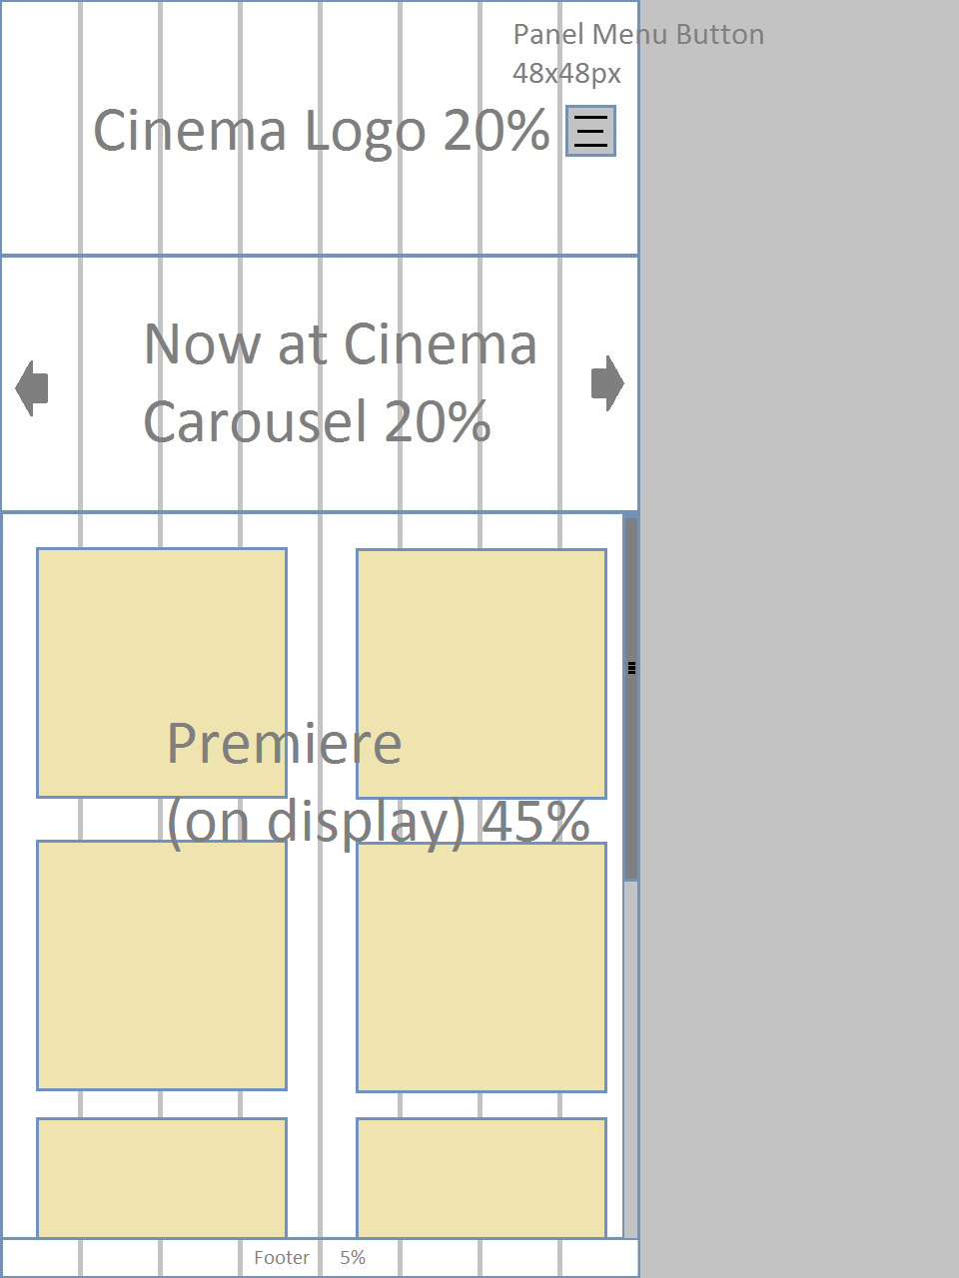**

**For Smartphones/IPhones / small screens:**

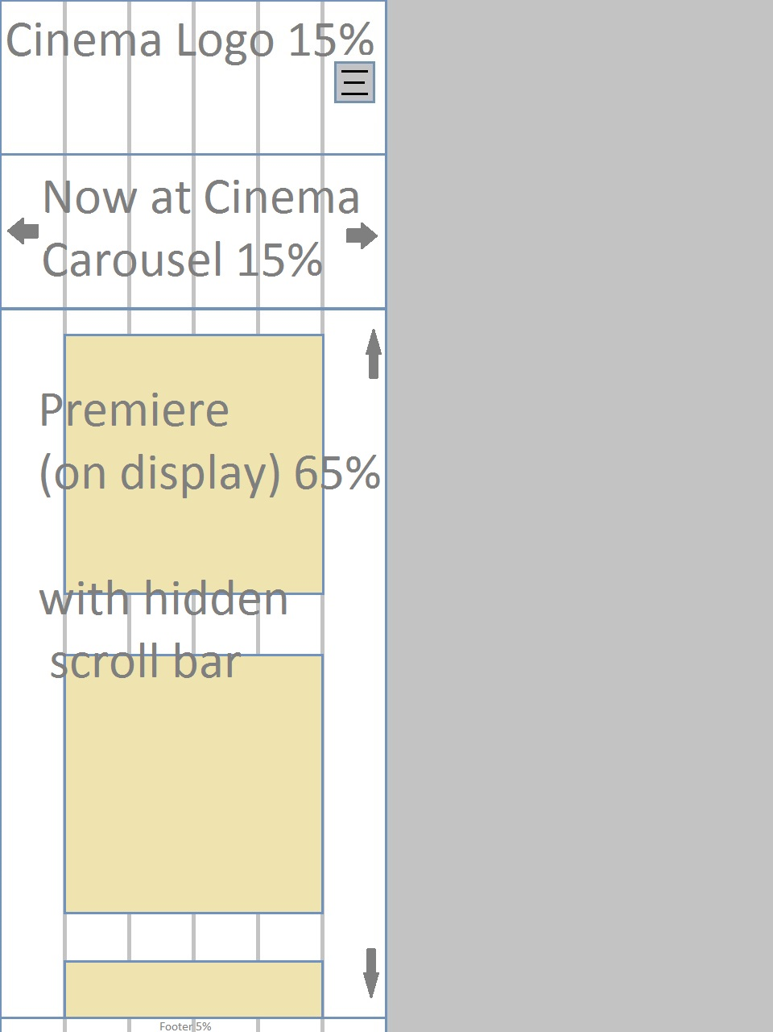

1. **Testing strategy:**For the testing I will use white box testingand all functions shown in the table below will have to be checked for the website to be considered complete and functional end product:

|  |  |  |
| --- | --- | --- |
| Testing functionality: | Checked: | Commentary |
| All links are functioning and providing to the stated content |  |  |
| Right pages are loading according to the size of the screen |  |  |
| Graphics are loading in expected size and order |  |  |
| All buttons are working and giving feedback message when necessary |  |  |
| Cinema basket (booking movies) functioning |  |  |
| Create login and password (register) |  |  |
| Logging to the user account |  |  |
| Forms are working and sending data to the server database |  |  |
| Responsive menu panel |  |  |